**FreePBX ARI Settings:**

Go to FreePBX portal and Press “Settings” and select “Advance Settings”.

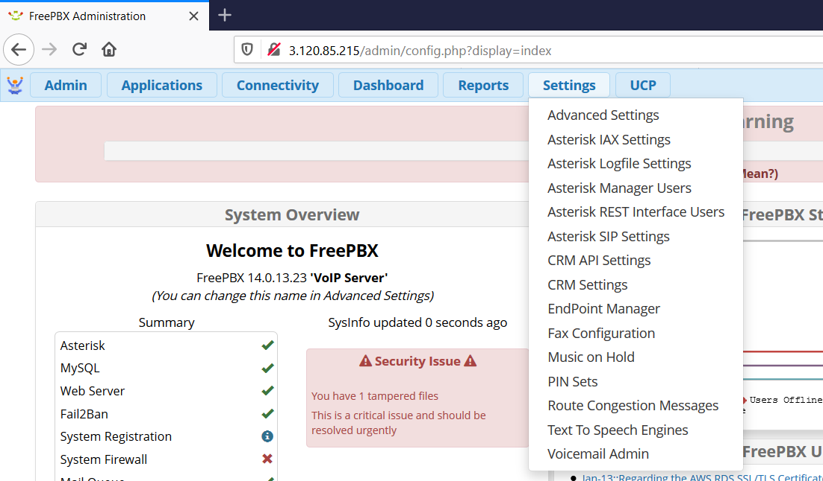

Check if ”Asterisk Builtin mini-HTTP server” is enabled as bellow on portal: (normally this setting is already set. You just need to verify it.)

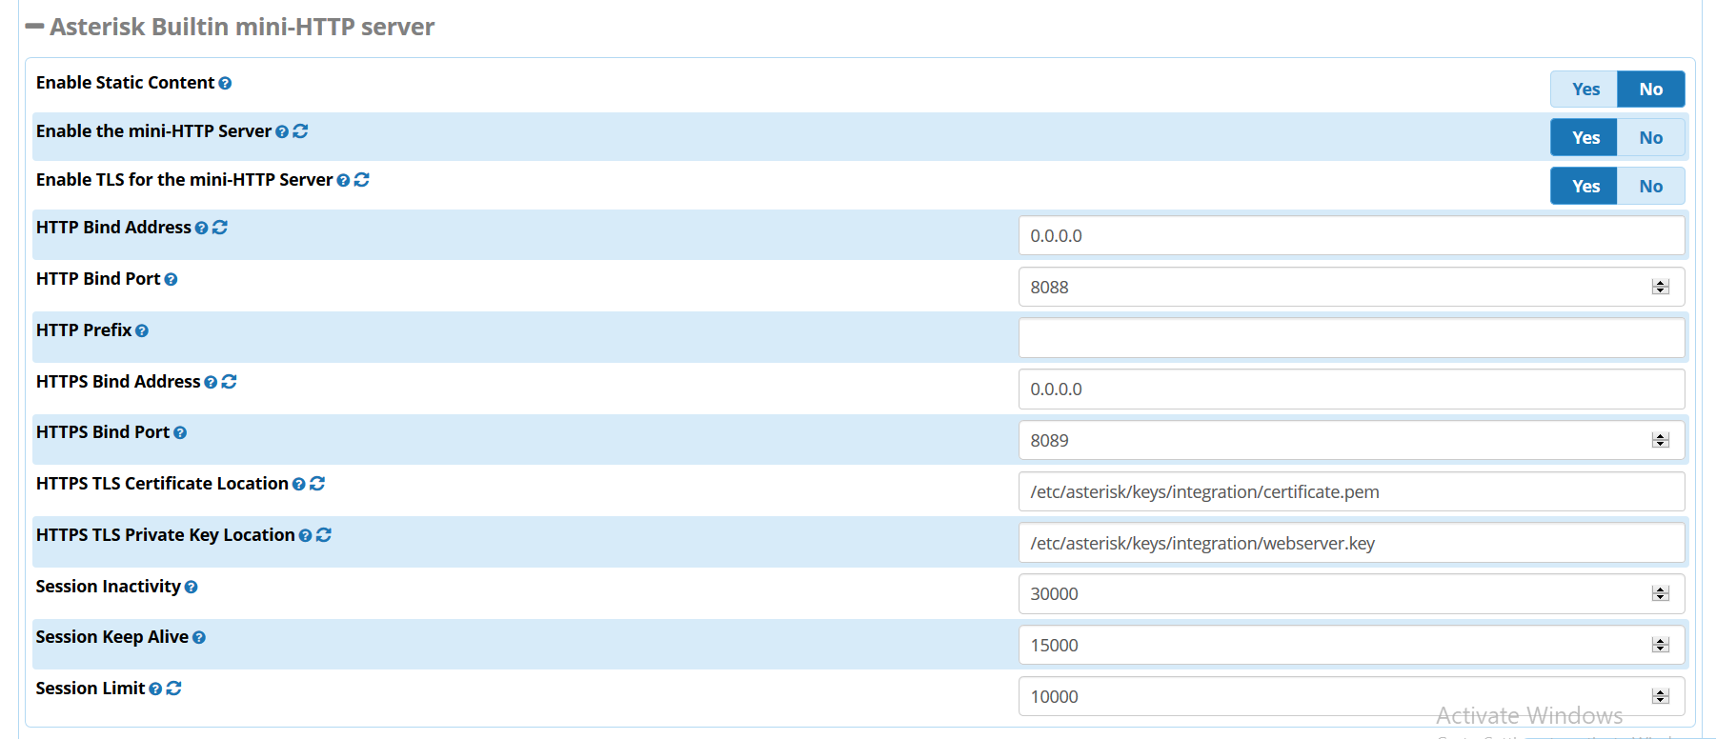

Go to “Asterisk REST Interface” is enabled as follows:

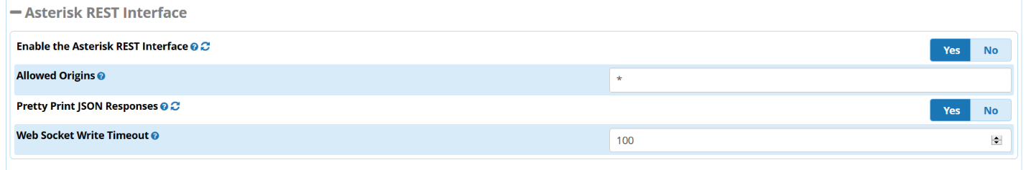

Now press “Settings” and select “Asterisk Rest Interface Users”

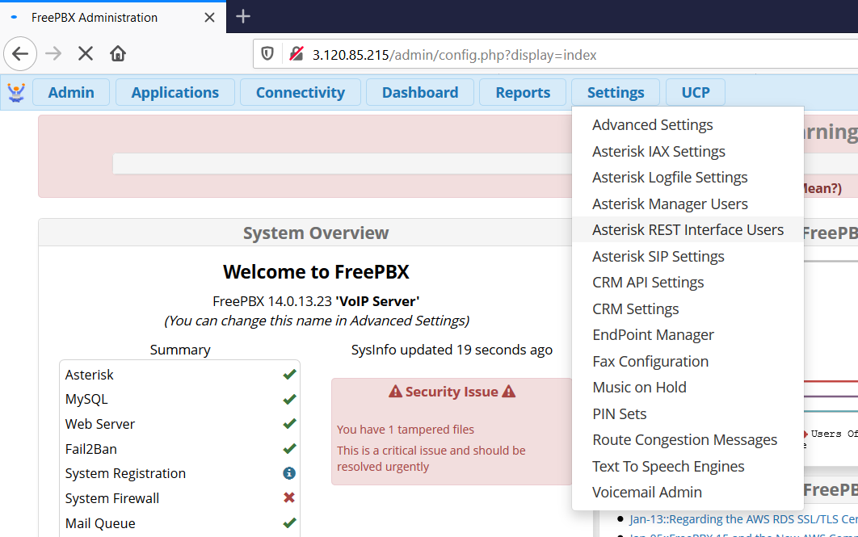

Press “Add User”



Set username and password and add user:

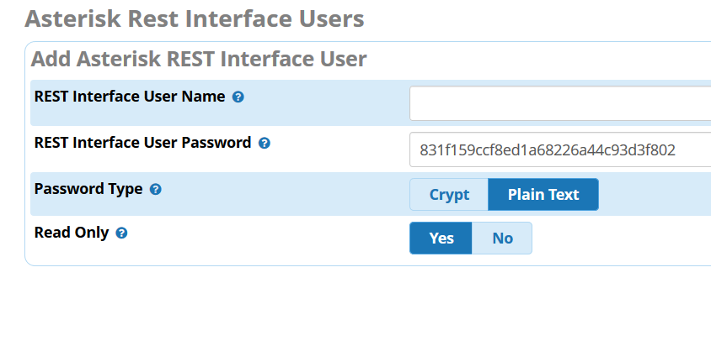**Set Stasis APP in Dial Plan:**

Open “extensions.conf” file in FreePBX system:

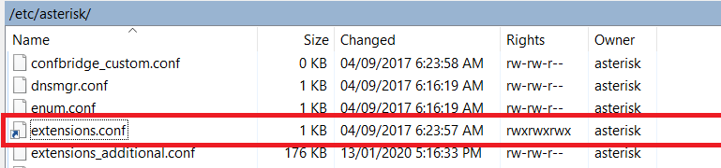

And add dial plan using stasis app corresponding to your line as following:

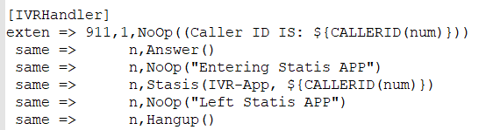

If all above configuration are correctly added ARI protocol is now up for vQube. Now you can use this ARI user and APP name in vQube ARI configuration: <https://github.com/virtualq/vQube-Release/wiki/2.-vQube-Dashborad-Configuration#ari-configuration>